Assignment 17.
- Create a standard internal table, fill the values and display them
- Goto SE38 transaction code
- Give Table name
- Create -> short description -> enter.
- REPORT will be created.
- Standard internal table program
- 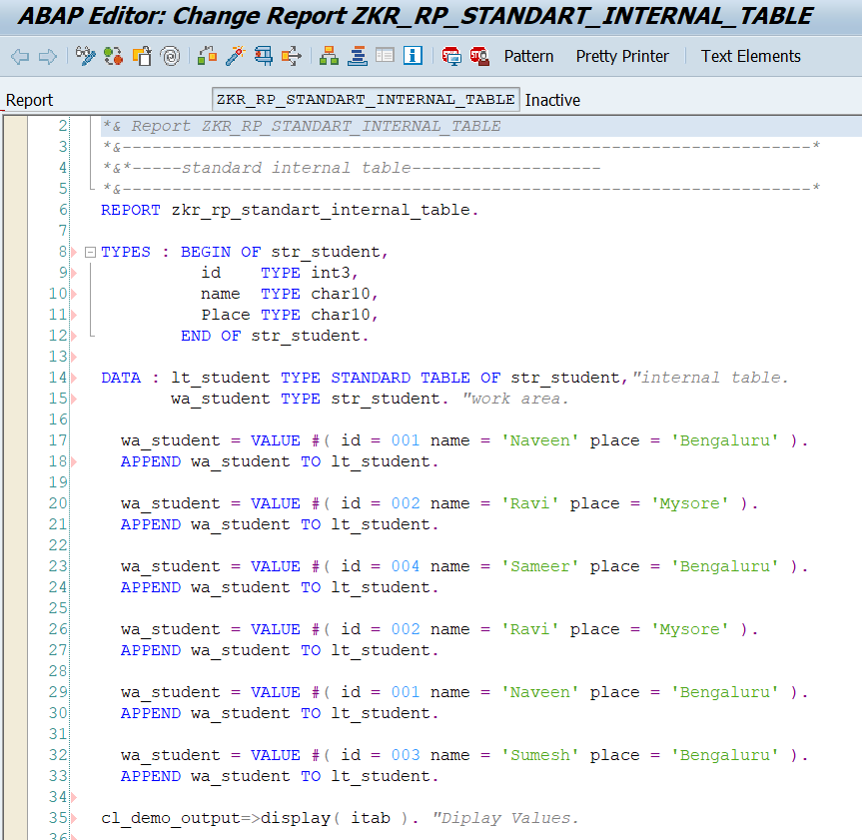

- 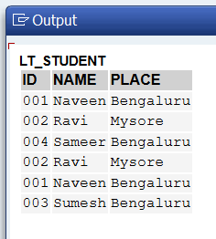
- Output (VALUES DISPLAYED).
- Create a standard internal table, fill the values, refresh it and again display the values.
- When we use REFRESH lt_student. In the standard table, the records are not visible. It removed all the records.
- 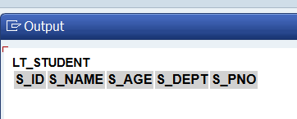

- Create a sorted internal table, fill the values and display them
- Goto SE38 transaction code
- Give Table name
- Create -> short description -> enter.
- REPORT will be created.
- Sorted internal table program
- 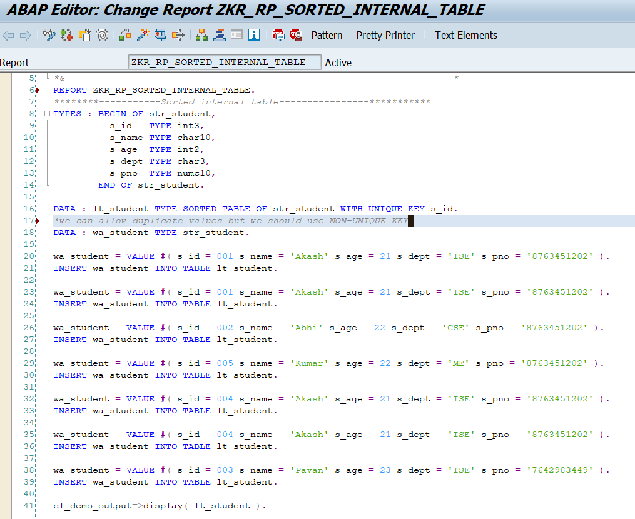
- 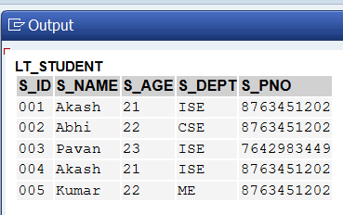
- Output.
- Duplicate values are not allowed.
- Values are displayed in sorted order(Ascending order).

- create a hashed internal table, fill the values and display them
- Goto SE38 transaction code
- Give Table name
- Create -> short description -> enter.
- REPORT will be created.
- Hashed internal table program
- 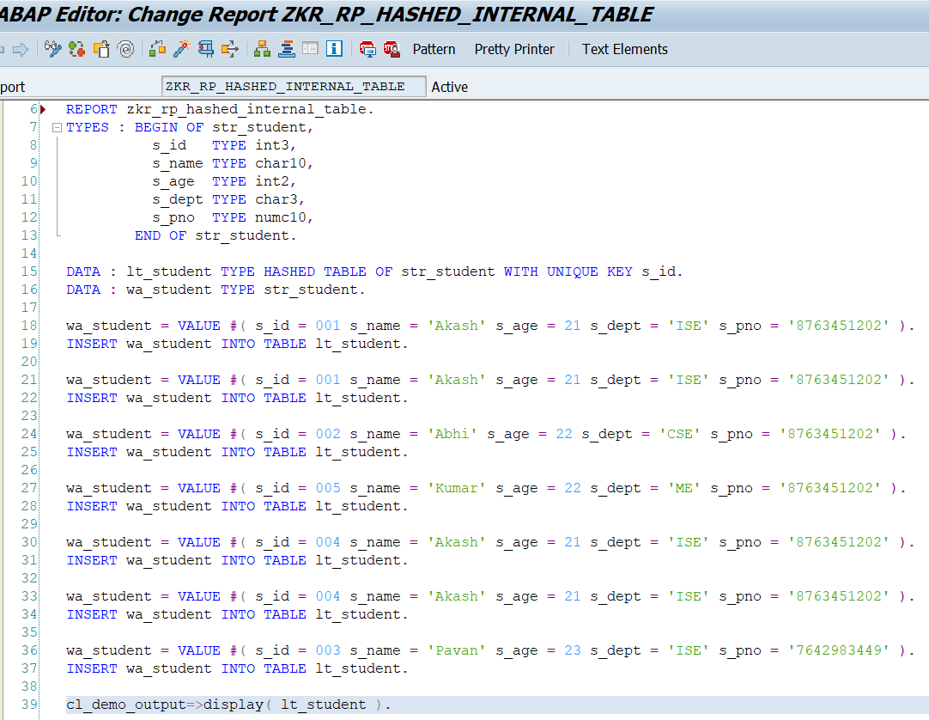

- 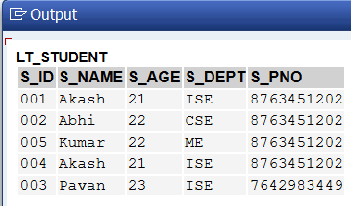
- Output.

- Transfer the data from one internal table to another internal table.

